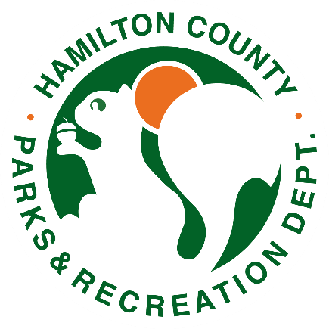

Potter’s Bridge Park Playground

Request for Proposals:

Sealed bid proposals for the Potter’s Bridge Park Playground, 19401 N Allisonville Rd, Noblesville, IN 46060 will be received by the Hamilton County Parks & Recreation Department's office, 400 Lafayette Road, Noblesville, IN 46060, until 4:30 p.m. (Local time) on Thursday, March 27, 2025.

1. The location of the playground shall be installed at the same location of the existing structures at Potter’s Bridge Park, 19401 N Allisonville Rd, Noblesville, IN 46060.
2. The new playground shall have a play area for 5–12-year-old children. Two proposals are to be provided – one nature-based playground and one modern playground. Designs can be creative for imaginative play value.

1. Existing play structures are to be removed and disposed from the park site by Hamilton County Parks & Recreation staff.
2. All playground structures must meet the ASTM F1487-17 standards.
3. The restroom building, trails, and walk paths will remain in the existing location unless bidder provides additional ADA accessible routes.
4. The size of the playground shall encompass the existing playground space. Expansion or reduction of this play area is unauthorized. However, consideration and plans should be presented in this proposal for drainage, slope, fill, soil extraction/removal, property lines, trails, and utilities, etc.
5. Access: The current access from the asphalt walkways into the engineered wood fiber is a concrete walkway surrounding the entire playground. If damaged or removed during construction they will need to be replaced/relocate to meet the existing conditions, not creating trip or safety hazards. The walkway slope shall not be greater that a 1/12 slope.
6. Drainage: Proper drainage is required. Provide plans and specs of drainage plans.
7. Surfacing: The playground surfacing is to be engineered wood fiber meeting the ASTM F2223-15 standards and installed by Hamilton County Parks & Recreation staff upon playground completion.
8. Grade: Finish grade and topsoil may/shall be required due to damage or disturbed areas during the construction. Seed will be provided by owner. Seed and straw installation with a germination rate of 80% by 1 year.
9. Construction of the playground shall be completed by September 1st, 2025 or started after October 10th, 2025. Safety fencing will be required to prevent the public from entering construction area during construction.
10. Warranty and workmanship: Please provide a minimum of 1 year warranty.
11. Certificate of insurance must be provided with a minimum of $1,000,000.00 general limited liability listing Hamilton County Parks and Recreation Department as an additional insured.
12. The above referenced playground project should be bid as a whole project and be submitted on a Form 96 bid format, with all pages of the form required.
13. The Park Board reserves the right to accept all or part of any bid or reject all bids. Once the bid is awarded and a contract signed the successful bidder may begin work as soon as possible. Bidders must specify in the bid when the work will begin, an expected completion date should be included as well.
14. Bids must be accompanied by the completed Non-Collusion Affidavit and Non-Discrimination Clause forms.
15. A successful bidder must also provide an accepted check or satisfactory bond by an incorporated surety company in good standing qualified to do business in the state of Indiana, in an amount equal to five percent (5%) of said bid, said deposit being for the purpose in ensuring the execution of the contract for which the bid is made.
16. All bidders must also be able provide E-Verify paperwork.
17. The contractor to whom the work is awarded shall be required to furnish a performance bond and a payment bond acceptable to the owner each in the amount of one hundred percent (100%) of the contract price unless waived by the owner.
18. No bidder may withdraw his bid for a period of sixty (60) days following the date set for receiving bids. The owner reserves the right to hold any and all bids for a period of not more than sixty (60) days and said bids shall be and remain valid and in full force and effect during said period.
19. The owner further reserves the right to waive informalities and to award the contract to the lowest, most responsive and responsible bidder, all to the advantage of the owner, or to reject any and all bids.
20. Plans, specifications, and contract are available at the Hamilton County Parks and Recreation Department Administration Office at the address given above. The telephone number for the Hamilton County Parks and Recreation Department is (317) 770-4400.
21. Park Department has a budget for this project of $140,000.00. Project must not exceed this amount. Projects will be judged on creativity and play value of the proposed playground.
22. No oral modifications or changes will be binding on either party. All changes in plans and specifications must be in writing and submitted prior to the pre-bid conference.