

From Original Order

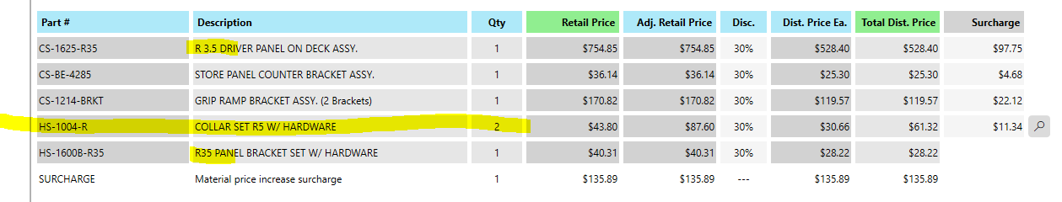

Your parts list has the wrong part number for the R35 collars.

