CPSC 2010 HANDBOOK HIGHLIGHTS
Comment on the Americans with Disabilities Act Accessibility Guidelines (ADAAG)
Found in section (1.6 Background):
“Playground designers, installers and operators should be aware that the Americans with Disabilities Act of 1990 (ADA) is a comprehensive civil rights law which prohibits discrimination on the basis of disability. Titles II and III of the ADA require, among other things, that newly constructed and altered State and local government facilities, places of public accommodation, and commercial facilities be readily accessible to and usable by individuals with disabilities. Recreation facilities, including play areas, are among the types of facilities covered by titles II and III of the ADA.”

The most common sections on what to look for when designing/auditing are…
2.2 Playground Layout
There are several key factors to keep in mind when laying out a playground:
• Accessibility
• Age separation
• Conflicting activities
• Sight lines
• Signage and/or labeling
• Supervision

2.2.1 Accessibility
Special consideration should be given to providing accessible surfaces in a play area that meets the ASTM Standard Specification for Determination of Accessibility of Surface Systems Under and Around Playground Equipment, ASTM F1951. Equipment selection and location along with the type of protective surfacing are key components to ensuring the opportunity for children with disabilities to play on the playground.
2.2.2 Age separation
For playgrounds intended to serve children of all ages, the layout of pathways and the landscaping of the playground should show the distinct areas for the different age groups. The areas should be separated at least by a buffer zone, which could be an area with shrubs or benches. This separation and buffer zone will reduce the chance of injury from older, more active children running through areas filled with younger children with generally slower movement and reaction times.

In areas where access to the playground is unlimited or enforced only by signage, the playground designer should recognize that since child development is fluid, parents and caregivers may select a playground slightly above or slightly below their child's abilities, especially for children at or near a cut-off age (e.g., 2-years old and 5-years old). This could be for ease of supervising multiple children, misperceptions about the hazards a playground may pose to children of a different age, advanced development of a child, or other reasons. For this reason, there is an overlap at age 5.
Developmentally a similar overlap also exists around age 2; however, due to the differences in ASTM standards and entrapment testing tools, this overlap is not reflected in the handbook. Playgrounds used primarily by children under the supervision of paid, trained professionals (e.g., child-care centers and schools) may wish to consider separating playgrounds by the facility's age groupings.
For example, a childcare facility may wish to limit a playground to toddlers under 2 exclusively and can draw information from this guide and ASTM F2373. A school, on the other hand, may have no children under 4 attending, and can likewise plan appropriately. Those who inspect playgrounds should use the intended age group of the playground.
2.2.4 Conflicting activities
The play area should be organized into different sections to prevent injuries caused by conflicting activities and children running between activities. Active, physical activities should be separate from more passive or quiet activities. Areas for playground equipment, open fields, and sand boxes should be located in different sections of the playground. In addition, popular, heavy-use pieces of equipment or activities should be dispersed to avoid crowding in any one area.
Different types of equipment have different use zones that must be maintained. The following are general recommendations for locating equipment within the playground site. Specific use zones for equipment are given in §5.3.
• Moving equipment, such as swings and merry-go-rounds, should be located toward a corner, side, or edge of the play area while ensuring that the appropriate use zones around the equipment are maintained.
• Slide exits should be located in an uncongested area of the playground.
• Composite play structures have become increasingly popular on public playgrounds. Adjacent components on composite structures should be complementary. For example, an access component should not be located in a slide exit zone.
2.2.5 Sight lines
Playgrounds that are designed, installed, and maintained in accordance with safety guidelines and standards can still present hazards to children. Playgrounds should be laid out to allow parents or caregivers to keep track of children as they move throughout the playground environment. Visual barriers should be minimized as much as possible. For example, in a park situation, playground equipment should be as visible as possible from park benches. In playgrounds with areas for different ages, the older children’s area should be visible from the younger children’s area to ensure that caregivers of multiple children can see older children while they are engaged in interactive play with younger ones.
2.2.6 Signage and/or labeling
Although the intended user group should be obvious from the design and scale of equipment, signs and/or labels posted in the playground area or on the equipment should give some guidance to supervisors as to the age appropriateness of the equipment.
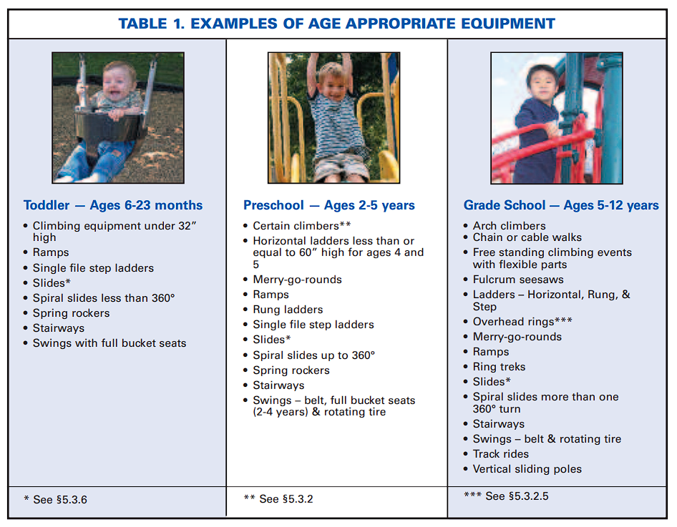
3. PLAYGROUND HAZARDS
This section provides a broad overview of general hazards that should be avoided on playgrounds. It is intended to raise awareness of the risks posed by each of these hazards. Many of these hazards have technical specifications and tests for compliance with ASTM F1487 and F2373. Some of these tests are also detailed in Appendix B.

3.1 Crush and Shearing Points
Anything that could crush or shear limbs should not be accessible to children on a playground. Crush and shear points can be caused by parts moving relative to each other or to a fixed part during a normal use cycle, such as a seesaw. To determine if there is a possible crush or shear point, consider:
• The likelihood a child could get a body part inside the point, and
• The closing force around the point. Potential crush/shear hazards specific to certain pieces of equipment are identified in §5.3 Major Types of Playground Equipment.
3.2 Entanglement and Impalement
Projections on playground equipment should not be able to entangle children’s clothing nor should they be large enough to impale. To avoid this risk:
• The diameter of a projection should not increase in the direction away from the surrounding surface toward the exposed end (see Figure 2).
• Bolts should not expose more than two threads beyond the end of the nut (see Figure 3).
• All hooks, such as S-hooks and C-hooks, should be closed (see also §5.3.8.1). A hook is considered closed if there is no gap or space greater than 0.04 inches, about the thickness of a dime. – Any connecting device containing an in-fill that completely fills the interior space preventing entry of clothing items into the interior of the device is exempt from this requirement.
• Swings and slides have additional recommendations for projections detailed in §5.3.
• See Appendix B for testing recommendations.
3.2.1 Strings and ropes
Drawstrings on the hoods of jackets, sweatshirts, and other upper body clothing can become entangled in playground equipment, and can cause death by strangulation. To avoid this risk:
• Children should not wear jewelry, jackets or sweatshirts with drawstring hoods, mittens connected by strings through the arms, or other upper body clothing with drawstrings.
• Remove any ropes, dog leashes, or similar objects that have been attached to playground equipment. Children can become entangled in them and strangle to death.
• Avoid equipment with ropes that are not secured at both ends.
• The following label, or a similar sign or label, can be placed on or near slides or other equipment where potential entanglements may occur.
3.3 Entrapment
3.3.1 Head entrapment
Head entrapment is a serious concern on playgrounds, since it could lead to strangulation and death. A child’s head may become entrapped if the child enters an opening either feet first or head first.
Head entrapment by head-first entry generally occurs when children place their heads through an opening in one orientation, turn their heads to a different orientation, then are unable to get themselves out. Head entrapment by feet first entry involves children who generally sit or lie down and slide their feet into an opening that is large enough to permit their bodies to go through but is not large enough to permit their heads to go through.
A part or a group of parts should not form openings that could trap a child’s head. Also, children should not wear their bicycle helmets while on playground equipment. There have been recent head entrapment incidents in which children wearing their bicycle helmets became entrapped in spaces that would not normally be considered a head entrapment.
Certain openings could present an entrapment hazard if the distance between any interior opposing surfaces is greater than 3.5 inches and less than 9 inches. These spaces should be tested as recommended in Appendix B. When one dimension of an opening is within this range, all dimensions of the opening should be considered together to evaluate the possibility of entrapment.
Even openings that are low enough for children’s feet to touch the ground can present a risk of strangulation for an entrapped child. (See Figure 4). Younger children may not have the necessary intellectual ability or motor skills to reverse the process that caused their heads to become trapped, especially if they become scared or panicked.
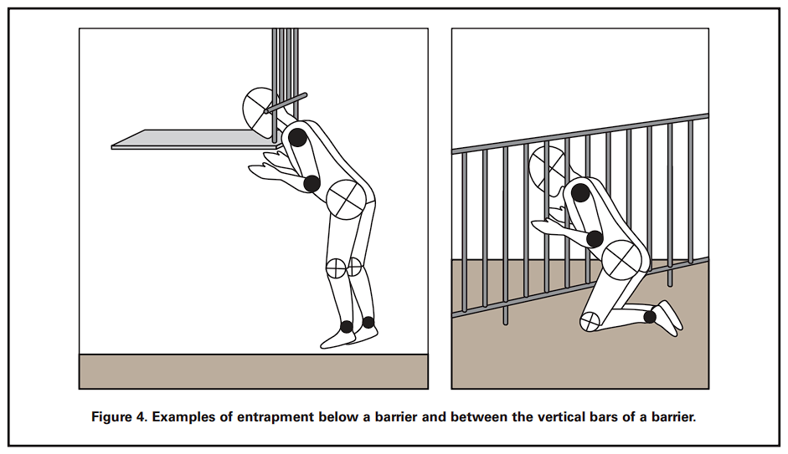
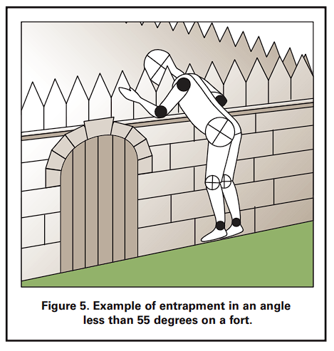
3.3.2 Partially bound openings and angles
Children can become entrapped by partially bound openings, such as those formed by two or more playground parts.
• Angles formed by two accessible adjacent parts should be greater than 55 degrees unless the lowest leg is horizontal or below horizontal.
• Use the partially-bound
opening test in Appendix B to identify hazardous angles and other partially-bound openings.
3.4 Sharp Points, Corners, and Edges
Sharp points, corners, or edges on any part of the playground or playground equipment may cut or puncture a child’s skin. Sharp edges can cause serious lacerations if protective measures are not taken. To avoid the risk of injury from sharp points, corners and edges:
• Exposed open ends of all tubing not resting on the ground or otherwise covered should be covered by caps or plugs that cannot be removed without the use of tools.
• Wood parts should be smooth and free from splinters.
• All corners, metal and wood, should be rounded.
• All metal edges should be rolled or have rounded capping.
• There should be no sharp edges on slides. Pay special attention to metal edges of slides along the sides and at the exit (see also §5.3.6.4).
• If steel-belted radials are used as playground equipment, they should be closely examined regularly to ensure that there are no exposed steel belts/wires.
• Conduct frequent inspections to help prevent injuries caused by splintered wood, sharp points, corners, or edges that may develop as a result of wear and tear on the equipment.
3.5 Suspended Hazards
Children using a playground may be injured if they run into or trip over suspended components (such as cables, wires, ropes, or other flexible parts) connected from one piece of the playground equipment to another or hanging to the ground. These suspended components can become hazards when they are within 45 degrees of horizontal and are less than 7 feet above the protective surfacing. To avoid a suspended hazard, suspended components:
• Should be located away from high traffic areas.
• Should either be brightly colored or contrast with the surrounding equipment and surfacing.
• Should not be able to be looped back on themselves or other ropes, cables, or chains to create a circle with a 5 inch or greater perimeter.
• Should be fastened at both ends unless they are 7 inches or less long or attached to a swing seat. These recommendations do not apply to swings, climbing nets, or if the suspended component is more than 7 feet above the protective surfacing and is a minimum of one inch at its widest cross-section dimension.
3.6 Tripping Hazards
Play areas should be free of tripping hazards (i.e., sudden change in elevations) to children who are using a playground. Two common causes of tripping are anchoring devices for playground equipment and containment walls for loose-fill surfacing materials.
• All anchoring devices for playground equipment, such as concrete footings or horizontal bars at the bottom of flexible climbers, should be installed below ground level and beneath the base of the protective surfacing material. This will also prevent children from sustaining additional injuries from impact if they fall on exposed footings.
• Contrasting the color of the surfacing with the equipment color can contribute to better visibility.
• Surfacing containment walls should be highly visible.
• Any change of elevation should be obvious.
• Contrasting the color of the containment barrier with the surfacing color can contribute to better visibility.
There are a number of different standards that are not mentioned in this document that we check for in playground layouts. Particularly, Section 5 “PARTS OF THE PLAYGROUND” and all its subsections (5.1 - 5.3.10) contain very useful information that we often look out for. If you need a copy of the CPSC Handbook for further review or have any questions, please contact Aaron or Alyssa.

