**2010 ADA Guidelines Highlights/Study Guide**

Applicable Definitions:

* **Elevated Play Component.** A play component that is approached above or below grade and that is part of a composite play structure consisting of two or more play components attached or functionally linked to create an integrated unit providing more than one play activity.
* **Ground Level Play Component.** A play component that is approached and exited at the ground level.
* **Play Area.** A portion of a site containing play components designed and constructed for children.
* **Play Component.** An element intended to generate specific opportunities for play, socialization, or learning. Play components are manufactured or natural; and are stand-alone or part of a composite play structure.
* **Soft Contained Play Structure.** A play structure made up of one or more play components where the user enters a fully enclosed play environment that utilizes pliable materials, such as plastic, netting, or fabric.
* **Use Zone.** The ground level area beneath and immediately adjacent to a play structure or play equipment that is designated by ASTM F 1487 (incorporated by reference, see “Referenced Standards” in Chapter 1) for unrestricted circulation around the play equipment and where it is predicted that a user would land when falling from or exiting the play equipment.

**Section 240 – Play Areas**

**240.1 General**. Play areas for children ages 2 and over shall comply with 240. Where separate play areas are provided within a site for specific age groups, each play area shall comply with 240.

**EXCEPTIONS:**

1. Play areas located in family childcare facilities where the proprietor actually resides shall not be required to comply with 240.

2. In existing play areas, where play components are relocated for the purposes of creating safe use zones and the ground surface is not altered or extended for more than one use zone, the play area shall not be required to comply with 240.

3. Amusement attractions shall not be required to comply with 240.

4. Where play components are altered and the ground surface is not altered, the ground surface shall not be required to comply with 1008.2.6 unless required by 202.4.

**Advisory 240.1 General.** Play areas may be located on exterior sites or within a building. Where separate play areas are provided within a site for children in specified age groups (e.g., preschool (ages 2 to 5) and school age (ages 5 to 12)), each play area must comply with this section. Where play areas are provided for the same age group on a site but are geographically separated (e.g., one is located next to a picnic area and another is located next to a softball field), they are considered separate play areas and each play area must comply with this section.

**240.1.1 Additions.** Where play areas are designed and constructed in phases, the requirements of 240 shall apply to each successive addition so that when the addition is completed, the entire play area complies with all the applicable requirements of 240.

**Advisory 240.1.1 Additions.** These requirements are to be applied so that when each successive addition is completed, the entire play area complies with all applicable provisions. For example, a play area is built in two phases. In the first phase, there are 10 elevated play components and 10 elevated play components are added in the second phase for a total of 20 elevated play components in the play area. When the first phase was completed, at least 5 elevated play components, including at least 3 different types, were to be provided on an accessible route. When the second phase is completed, at least 10 elevated play components must be located on an accessible route, and at least 7 ground level play components, including 4 different types, must be provided on an accessible route. At the time the second phase is complete, ramps must be used to connect at least 5 of the elevated play components and transfer systems are permitted to be used to connect the rest of the elevated play components required to be located on an accessible route.

**240.2 Play Components.** Where provided, play components shall comply with 240.2.

**240.2.1 Ground Level Play Components.** Ground level play components shall be provided in the number and types required by 240.2.1. Ground level play components that are provided to comply with 240.2.1.1 shall be permitted to satisfy the additional number required by 240.2.1.2 if the minimum required types of play components are satisfied. Where two or more required ground level play components are provided, they shall be dispersed throughout the play area and integrated with other play components.

**Advisory 240.2.1 Ground Level Play Components.** Examples of ground level play components may include spring rockers, swings, diggers, and stand-alone slides. When distinguishing between the different types of ground level play components, consider the general experience provided by the play component. Examples of different types of experiences include, but are not limited to, rocking, swinging, climbing, spinning, and sliding.

**Advisory 240.2.1 Ground Level Play Components (Continued).** A spiral slide may provide a slightly different experience from a straight slide, but sliding is the general experience and therefore a spiral slide is not considered a different type of play component from a straight slide. Ground level play components accessed by children with disabilities must be integrated into the play area. Designers should consider the optimal layout of ground level play components accessed by children with disabilities to foster interaction and socialization among all children. Grouping all ground level play components accessed by children with disabilities in one location is not considered integrated. Where a stand-alone slide is provided, an accessible route must connect the base of the stairs at the entry point to the exit point of the slide. A ramp or transfer system to the top of the slide is not required. Where a sand box is provided, an accessible route must connect to the border of the sand box. Accessibility to the sand box would be enhanced by providing a transfer system into the sand or by providing a raised sand table with knee clearance complying with 1008.4.3.

**Advisory 240.2.1 Ground Level Play Components (Continued).** Ramps are preferred over transfer systems since not all children who use wheelchairs or other mobility devices may be able to use, or may choose not to use, transfer systems. Where ramps connect elevated play components, the maximum rise of any ramp run is limited to 12 inches (305 mm). Where possible, designers and operators are encouraged to provide ramps with a slope less than the 1:12 maximum. Berms or sculpted dirt may be used to provide elevation and may be part of an accessible route to composite play structures.

**240.2.1.1 Minimum Number and Types**. Where ground level play components are provided, at least one of each type shall be on an accessible route and shall comply with 1008.4.

**240.2.1.2 Additional Number and Types.** Where elevated play components are provided, ground level play components shall be provided in accordance with Table 240.2.1.2 (below) and shall comply with 1008.4.

**EXCEPTION:** If at least 50 percent of the elevated play components are connected by a ramp and at least 3 of the elevated play components connected by the ramp are different types of play components, the play area shall not be required to comply with 240.2.1.2.

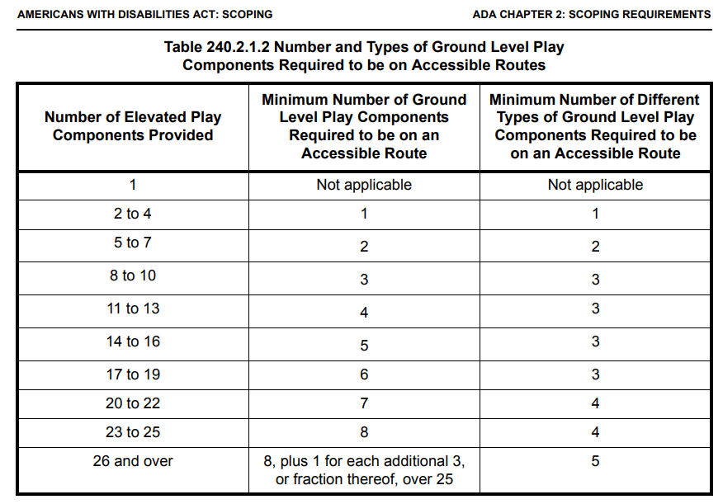

**Advisory 240.2.1.2 Additional Number and Types**. Where a large play area includes two or more composite play structures designed for the same age group, the total number of elevated play components on all the composite play structures must be added to determine the additional number and types of ground level play components that must be provided on an accessible route.

**240.2.2 Elevated Play Components.** Where elevated play components are provided, at least 50 percent shall be on an accessible route and shall comply with 1008.4.

**Advisory 240.2.2 Elevated Play Components**. A double or triple slide that is part of a composite play structure is one elevated play component. For purposes of this section, ramps, transfer systems, steps, decks, and roofs are not considered elevated play components. Although socialization and pretend play can occur on these elements, they are not primarily intended for play. Some play components that are attached to a composite play structure can be approached or exited at the ground level or above grade from a platform or deck. For example, a climber attached to a composite play structure can be approached or exited at the ground level or above grade from a platform or deck on a composite play structure.

**Advisory 240.2.2 Elevated Play Components (Continued).** Play components that are attached to a composite play structure and can be approached from a platform or deck (e.g., climbers and overhead play components) are considered elevated play components. These play components are not considered ground level play components and do not count toward the requirements in 240.2.1.2 regarding the number of ground level play components that must be located on an accessible route.

**Section 1008 – Play Areas**

**1008.1 General.** Play areas shall comply with 1008.

**1008.2 Accessible Routes.** Accessible routes serving play areas shall comply with Chapter 4 and 1008.2 and shall be permitted to use the exceptions in 1008.2.1 through 1008.2.3. Where accessible routes serve ground level play components, the vertical clearance shall be 80 inches high (2030 mm) minimum.

**1008.2.1 Ground Level and Elevated Play Components.** Accessible routes serving ground level play components and elevated play components shall be permitted to use the exceptions in 1008.2.1.

**EXCEPTIONS:**

1. Transfer systems complying with 1008.3 shall be permitted to connect elevated play components except where 20 or more elevated play components are provided no more than 25 percent of the elevated play components shall be permitted to be connected by transfer systems.

2. Where transfer systems are provided, an elevated play component shall be permitted to connect to another elevated play component as part of an accessible route.

**1008.2.2 Soft Contained Play Structures.** Accessible routes serving soft contained play structures shall be permitted to use the exception in 1008.2.2.

**EXCEPTION:** Transfer systems complying with 1008.3 shall be permitted to be used as part of an accessible route.

*(This next subsection pertains to splash pads, just good information to have. We don’t directly supply splash pad/water equipment).*

***1008.2.3 Water Play Components.*** *Accessible routes serving water play components shall be permitted to use the exceptions in 1008.2.3.*

***EXCEPTIONS:***

*1. Where the surface of the accessible route, clear floor or ground spaces, or turning spaces serving water play components is submerged, compliance with 302, 403.3, 405.2, 405.3, and 1008.2.6 shall not be required.*

*2. Transfer systems complying with 1008.3 shall be permitted to connect elevated play components in water.*

***Advisory 1008.2.3 Water Play Components.*** *Personal wheelchairs and mobility devices may not be appropriate for submerging in water when using play components in water. Some may have batteries, motors, and electrical systems that when submerged in water may cause damage to the personal mobility device or wheelchair or may contaminate the water. Providing an aquatic wheelchair made of non-corrosive materials and designed for access into the water will protect the water from contamination and avoid damage to personal wheelchairs.*

**1008.2.4 Clear Width.** Accessible routes connecting play components shall provide a clear width complying with 1008.2.4.

**1008.2.4.1 Ground Level.** At ground level, the clear width of accessible routes shall be 60 inches (1525 mm) minimum.

**EXCEPTIONS:**

1. In play areas less than 1000 square feet (93 m2), the clear width of accessible routes shall be permitted to be 44 inches (1120 mm) minimum, if at least one turning space complying with 304.3 is provided where the restricted accessible route exceeds 30 feet (9145 mm) in length.

2. The clear width of accessible routes shall be permitted to be 36 inches (915 mm) minimum for a distance of 60 inches (1525 mm) maximum provided that multiple reduced width segments are separated by segments that are 60 inches (1525 mm) wide minimum and 60 inches (1525 mm) long minimum.

**1008.2.4.2 Elevated.** The clear width of accessible routes connecting elevated play components shall be 36 inches (915 mm) minimum.

**EXCEPTIONS:**

1. The clear width of accessible routes connecting elevated play components shall be permitted to be reduced to 32 inches (815 mm) minimum for a distance of 24 inches (610 mm) maximum provided that reduced width segments are separated by segments that are 48 inches (1220 mm) long minimum and 36 inches (915 mm) wide minimum.

2. The clear width of transfer systems connecting elevated play components shall be permitted to be 24 inches (610 mm) minimum.

**1008.2.5 Ramps.** Within play areas, ramps connecting ground level play components and ramps connecting elevated play components shall comply with 1008.2.5.

**1008.2.5.1 Ground Level.** Ramp runs connecting ground level play components shall have a running slope not steeper than 1:16.

**1008.2.5.2 Elevated.** The rise for any ramp run connecting elevated play components shall be 12 inches (305 mm) maximum.

**1008.2.5.3 Handrails.** Where required on ramps serving play components, the handrails shall comply with 505 except as modified by 1008.2.5.3.

**EXCEPTIONS:**

1. Handrails shall not be required on ramps located within ground level use zones.

2. Handrail extensions shall not be required. 1008.2.5.3.1 Handrail Gripping Surfaces. Handrail gripping surfaces with a circular cross section shall have an outside diameter of 0.95 inch (24 mm) minimum and 1.55 inches (39 mm) maximum. Where the shape of the gripping surface is non-circular, the handrail shall provide an equivalent gripping surface. 1008.2.5.3.2 Handrail Height. The top of handrail gripping surfaces shall be 20 inches (510 mm) minimum and 28 inches (710 mm) maximum above the ramp surface.

**1008.2.6 Ground Surfaces.** Ground surfaces on accessible routes, clear floor or ground spaces, and turning spaces shall comply with 1008.2.6.

**Advisory 1008.2.6 Ground Surfaces.** Ground surfaces must be inspected and maintained regularly to ensure continued compliance with the ASTM F 1951 standard. The type of surface material selected and play area use levels will determine the frequency of inspection and maintenance activities.

**1008.2.6.1 Accessibility.** Ground surfaces shall comply with ASTM F 1951 (incorporated by reference, see “Referenced Standards” in Chapter 1). Ground surfaces shall be inspected and maintained regularly and frequently to ensure continued compliance with ASTM F 1951.

**1008.2.6.2 Use Zones.** Ground surfaces located within use zones shall comply with ASTM F 1292 (1999 edition or 2004 edition) (incorporated by reference, see “Referenced Standards” in Chapter 1).

**1008.3 Transfer Systems.** Where transfer systems are provided to connect to elevated play components, transfer systems shall comply with 1008.3.

**Advisory 1008.3 Transfer Systems.** Where transfer systems are provided, consideration should be given to the distance between the transfer system and the elevated play components. Moving between a transfer platform and a series of transfer steps requires extensive exertion for some children. Designers should minimize the distance between the points where a child transfers from a wheelchair or mobility device and where the elevated play components are located. Where elevated play components are used to connect to another elevated play component instead of an accessible route, careful consideration should be used in the selection of the play components used for this purpose.

**1008.3.1** Transfer Platforms. Transfer platforms shall be provided where transfer is intended from wheelchairs or other mobility aids. Transfer platforms shall comply with 1008.3.1. 1008.3.1.1 Size. Transfer platforms shall have level surfaces 14 inches (355 mm) deep minimum and 24 inches (610 mm) wide minimum.

**1008.3.1.2** Height. The height of transfer platforms shall be 11 inches (280 mm) minimum and 18 inches (455 mm) maximum measured to the top of the surface from the ground or floor surface.

**1008.3.1.3** Transfer Space. A transfer space complying with 305.2 and 305.3 shall be provided adjacent to the transfer platform. The 48 inch (1220 mm) long minimum dimension of the transfer space shall be centered on and parallel to the 24 inch (610 mm) long minimum side of the transfer platform. The side of the transfer platform serving the transfer space shall be unobstructed.

**1008.3.1.4** Transfer Supports. At least one means of support for transferring shall be provided.

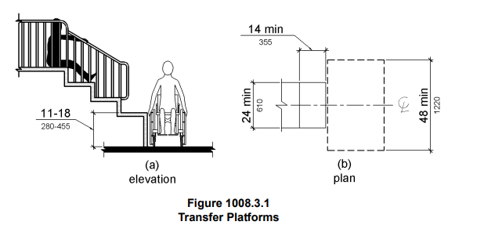

**1008.3.2 Transfer Steps.** Transfer steps shall be provided where movement is intended from transfer platforms to levels with elevated play components required to be on accessible routes. Transfer steps shall comply with 1008.3.2.

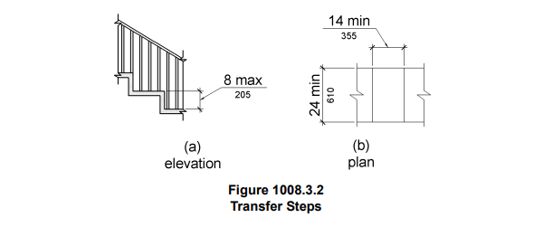

**1008.3.2.1 Size.** Transfer steps shall have level surfaces 14 inches (355 mm) deep minimum and 24 inches (610 mm) wide minimum.

**1008.3.2.2 Height.** Each transfer step shall be 8 inches (205 mm) high maximum. 1008.3.2.3 Transfer Supports. At least one means of support for transferring shall be provided.

**Advisory 1008.3.2.3 Transfer Supports.** Transfer supports are required on transfer platforms and transfer steps to assist children when transferring. Some examples of supports include a rope loop, a loop type handle, a slot in the edge of a flat horizontal or vertical member, poles or bars, or D rings on the corner posts.

**1008.4 Play Components.** Ground level play components on accessible routes and elevated play components connected by ramps shall comply with 1008.4.

**1008.4.1 Turning Space.** At least one turning space complying with 304 shall be provided on the same level as play components. Where swings are provided, the turning space shall be located immediately adjacent to the swing.

**1008.4.2 Clear Floor or Ground Space.** Clear floor or ground space complying with 305.2 and 305.3 shall be provided at play components.

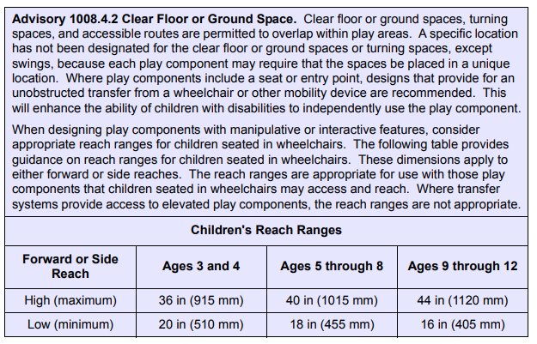

**1008.4.3 Play Tables.** Where play tables are provided, knee clearance 24 inches (610 mm) high minimum, 17 inches deep (430 mm) minimum, and 30 inches (760 mm) wide minimum shall be provided. The tops of rims, curbs, or other obstructions shall be 31 inches (785 mm) high maximum.

**EXCEPTION:** Play tables designed and constructed primarily for children 5 years and younger shall not be required to provide knee clearance where the clear floor or ground space required by 1008.4.2 is arranged for a parallel approach.

**1008.4.4 Entry Points and Seats.** Where play components require transfer to entry points or seats, the entry points or seats shall be 11 inches (280 mm) minimum and 24 inches (610 mm) maximum from the clear floor or ground space.

**EXCEPTION:** Entry points of slides shall not be required to comply with 1008.4.4.

**1008.4.5 Transfer Supports.** Where play components require transfer to entry points or seats, at least one means of support for transferring shall be provided.

END PLAYGROUND SEGMENTS - 2010 ADA GUIDELINES

*There are a lot of sections of the F1487 ASTM that reference these guidelines, the next few pages show several diagrams I found particularly fitting to include in this document. If you have any questions, please feel welcome to reach out to your team leads.*

* *Alyssa Gomez*

*Design Services Supervisor*

